

BOOK RENTAL SYSTEM
TEAM-A

G.Madhuri Pervez Mubeen Srivarsha Chivukula

Steps involved in making our website

- Backend (MySQL-python)
  - Webscraping (Beautiful soup-python)
  - Books table
  - Users table
  - Books rented table
- Frontend (CSS ,Html ,JavaScript)
  - Home page
  - Genre pages
  - Login/Signup page
- Framework (Django /Flask)

1.WEB SCRAPING
- WEBSITE: books to scrape.com
STEP-01: Details to be scraped from the website using python:
- Book id
- Book title
- Ratings
- Image source of book cover
- Price
- Availability
- Genre
- UPC id
- Product type
- Price including tax

1.WEB SCRAPING
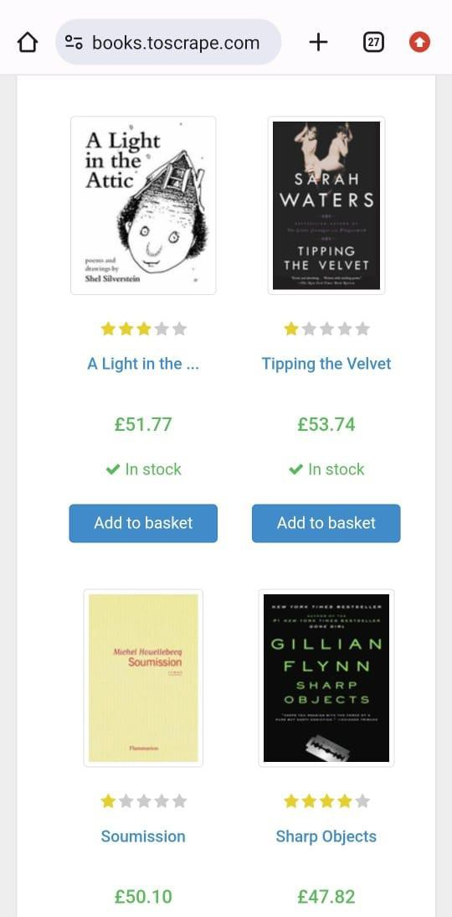
- Price excluding tax
- Tax
- Number of reviews
- Description

  - Save the scraped data in the form of respective lists(14)

THE WEBPAGE TO BE SCRAPED FROM IS SHOWN HERE!

WEB SCRAPING
- STEP-02: Convert the whole data into a dataframe using pandas module in python After conversion the dataframe should look like:

BOOK ID | BOOK TITLE | RATIN GS | IMG_ SRC | PRICE | In_ stock | genre | Upc id | Produ ct type | Price (excl. Tax) | Price (incl. Tax) | Tax | No.of revie ws | descri ption
1 | A light In the attic | 3 | https:  //boo ks.tos crape. com/. | 51.77 | TRUE | Poetry | a897f e39b 1053  632 | Books | 51.77 | 51.77 | 0 | 0 | It's hard to imag..
2 | Tippin g the Velvet | 1 | https:  //boo ks.tos crape. com/. | 53.74 | TRUE | Histor ical | 90fa6 1229  2611  40a | Books | 53.74 | 53.74 | 0 | 0 | Writte n with starlin g p…

WEB SCRAPING
  - STEP-03: Convert the data frame into a csv file to be used for further purposes at the time of
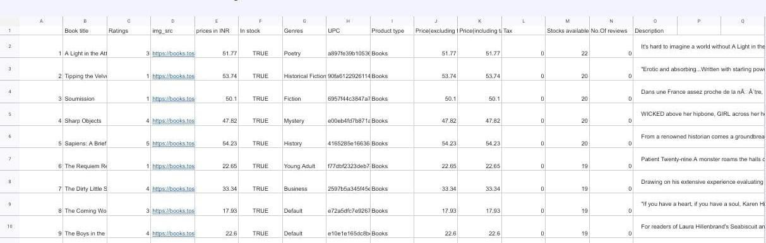
backend [books table in database] The file can be as shown below:

BACKEND: Database and Table Creation
    - We have created each of the following mentioned tables in the database with the help of the following platforms:
      - Python
      - MySQL Workbench

DATABASE: Books table
    - Attributes for books table:
- Book id
- Book title
- Book price
- Rating
- Genre
- UPC ID
- Price (excluding taxes)
- Price (including taxes)

DATABASE: Books table

- Tax
- Number of reviews
- Product type
- Image source
- In stock
- Number in stock
- Description

DATABASE: Books table
The books table should look like this

Book  id | Book  title | Book  Price | Ratin  g | Genr  e | UPC  ID | Price (inclu ding  tax) | Price (exclu ding  tax) | Tax | No of revie ws | Produ ct type | Img  src | In  Stock | No in  stock | Descr  iption
2100  1 | A  light in the Attic | 51.77 | 3 | Poetr y | a897  fe39b  1053  632 | 51.77 | 51.77 | 0 | 0 | Book |  | True | 22 | It’s hard to….
2100  1 | Tippi ng in the Velvet | 53.74 | 1 | Histor ical Fictio n | 90fa 6122  9261  140a | 53.74 | 53.74 | 0 | 0 | Book |  | True | 20 | It is an absor bing  …

2.DATABASE: Users table

- Attributes for users table:
- User id
- Username
- Password
- Email address
- Mobile number

2.DATABASE: Users table

The users table should look like below:

User id | Username | Password | Email address | Mobile number
1 | A | abc234 | abc@gmail.com | 1234567891
2 | B | def456 | def@gmail.com | 6789123456

2.DATABASE: Books rented table

- Attributes for books rented table:
- Transaction id [primary key]
- User id [foreign key from users table]
- Username [foreign key from users table]
- Book id [foreign key from books table]
- Book title [foreign key from books table]
- Due date
- Price

DATABASE: Books rented table
The table should be as shown below:

Transaction id | User id | User name | Book id | Book title | Due date | Price
628179247 | 1 | A | 2 | Tipping the Velvet | 28/07/2024 | 53
137126973 | 2 | B | 13 | Set Me Free | 12/10/2024 | 17

FRONTEND:

Technologies used for creating and designing webpages:-
- CSS
2.Html 3.JavaScript

To connect frontend to backend:-
1.Django / 2.Flask

HOME PAGE
My_Account Contact

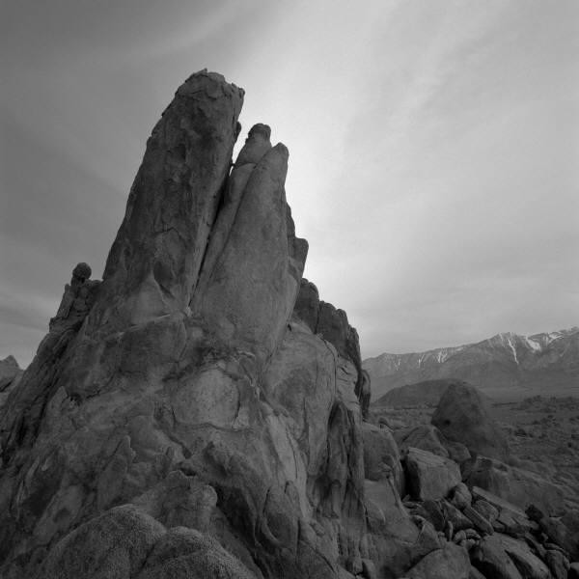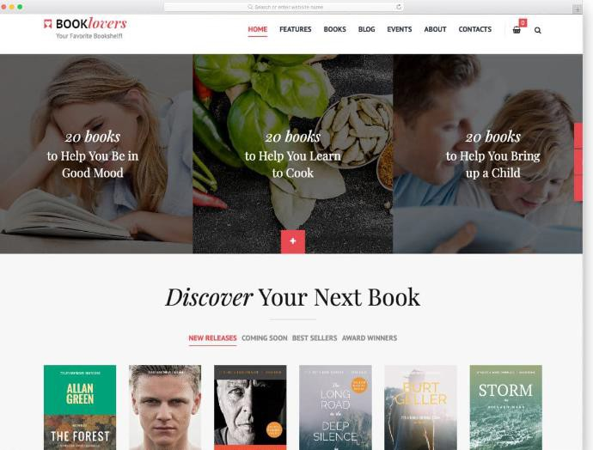 Our logo
CLASSIC PHOTO ALBUM
Explore Shop
Login/Signup

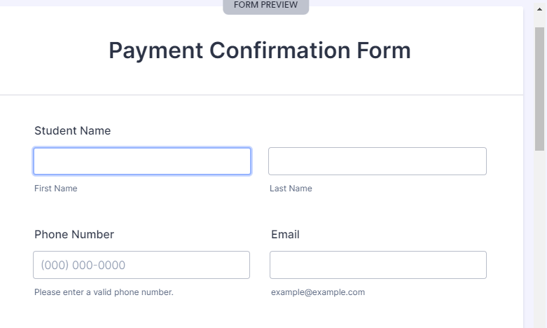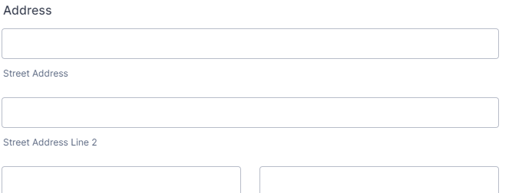Sign up /Login page

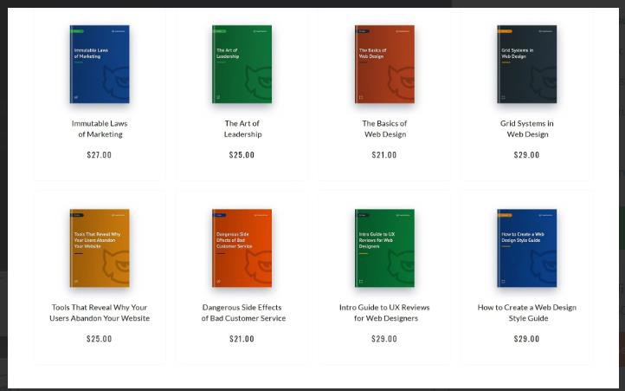GENRE PAGE

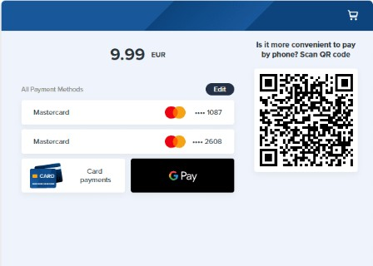

Amount of book rented



